Emily List

PHYS 306

09/23/2021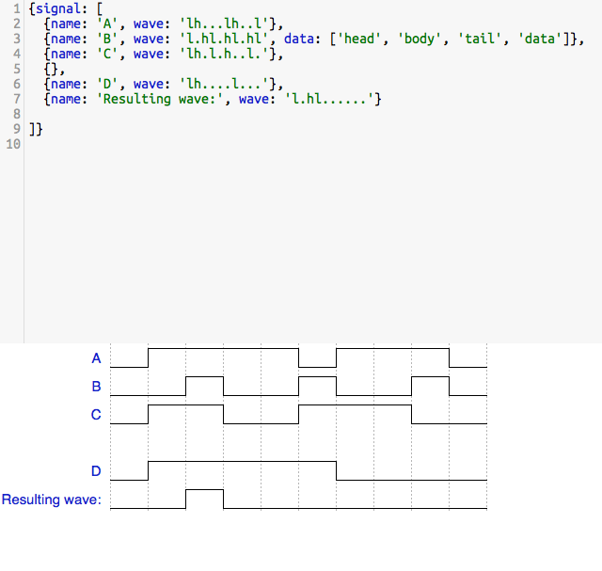

Section 3-2 #8

Section 3-3 #14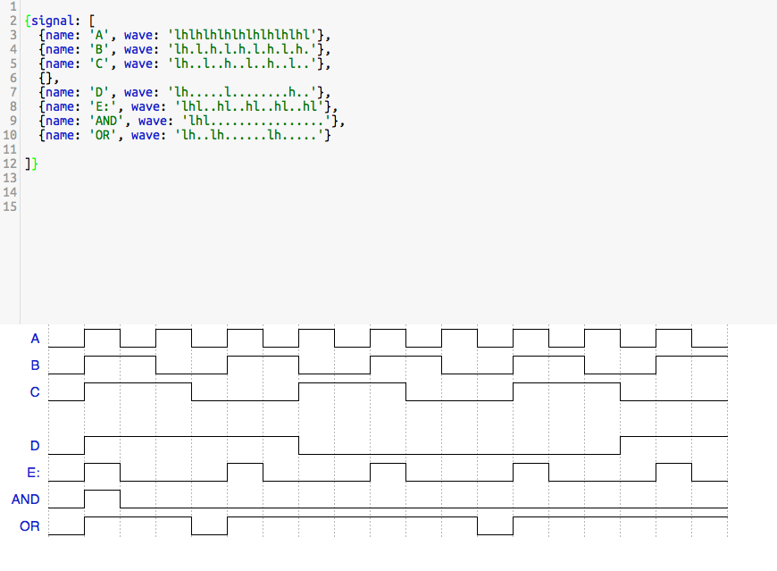

Section 3-4 #18